Profile of the

Metropolitan Enforcement Group
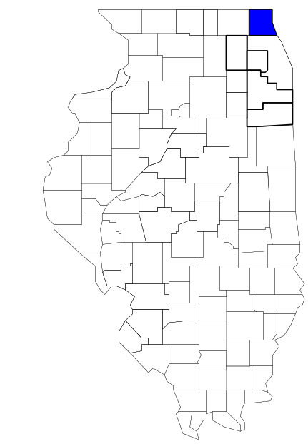of Lake County

Prepared by

The Research and Analysis Unit of the
Illinois Criminal Justice Information Authority

George H. Ryan, Governor
Peter B. Bensinger, Chairman
Candice M. Kane, Executive Director

March 2001
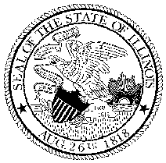

ILLINOIS
CRIMINAL JUSTICE
INFORMATION AUTHORITY

This project was supported by Grant # 99-DB-BX-0017, awarded to the Illinois Criminal Justice Information Authority by the Bureau of Justice Assistance, Office of Justice Programs, U.S. Department of Justice. The Assistant Attorney General, Office of Justice Programs, coordinates the activities of the following programs, offices and bureaus: Bureau of Justice Assistance, Bureau of Justice Statistics, National Institute of Justice, Office of Juvenile Justice and Delinquency Prevention, and the Office for Victims of Crime. Points of view or opinions contained within this document are those of the authors and do not necessarily represent the official position or policies of the U.S. Department of Justice.

Illinois Criminal Justice Information Authority
120 S. Riverside Plaza, Suite 1016
Chicago, Illinois 60606-3997
Telephone (312) 793-8550
Telefax (312) 793-8422
TDD: (312) 793-4170
World Wide Website http://www.icjia.state.il.us
ACKNOWLEDGMENTS

A number of organizations and individuals put a great deal of effort into the development of this document. The Authority’s Research and Analysis Unit is very grateful for the assistance provided by the following organizations:

Administrative Office of the Illinois Courts
Illinois Department of Human Services’ Office of Alcoholism and Substance Abuse
Illinois Department of Children and Family Services
Illinois Department of Corrections
Illinois State Police
Metropolitan Enforcement Group of Lake County
U.S. Bureau of the Census

In addition, the following individuals were instrumental in gathering, interpreting and presenting these data:

Sharyn Adams

Megan Alderden

Robert Bauer

Alissa Clark

John Condne

Karen Griffiths

Tracy Hahn

Jennifer Hiselman

David Katz

Joseph Kozenczak

Gary Kupsak

Erica Morrow

David Olson

Adrianna Perez

Gerard Ramker

Robert Taylor

CONTENTS

Section Page Number

EXECUTIVE SUMMARY

I. Introduction 1
II. Trends in Violent Index Offenses and Arrests 3
III. Trends in Drug Arrests 6
IV. Trends in Drug Seizures 14
V. Trends in Prosecutions for Drug Offenses 16
VI. Trends in Percent of Convicted Drug Offenders Sentenced to Prison 18
VII. Trends in Drug Treatment Admissions in Lake County, by Drug Type 23
VIII. Trends in Drug Exposed Births 26
IX. Summary of Drug Situation 2
7
X. Appendices 29
Map 1 1999 Percent of Illinois' County-level Population Covered by an
Authority-funded Multi-jurisdictional Enforcement Group or Task Force 30
Map 2 1999 Illinois Cannabis Seizure Rates, by County 31
Map 3 1999 Illinois Controlled Substances Seizure Rates, by County 32
Map 4 1999 Illinois Methamphetamine Seizure Rates, by County 33
XI. Bibliography 34

LIST OF FIGURES

Figure Page Number

Figure 1. Violent Index Offense Rates for Participating and Non-participating Agencies in Region Covered by MEGLC 3
Figure 2. 1999 Violent Index Offenses* Reported by Participating and Non-participating Agencies in Region Covered by MEGLC 4
Figure 3. Violent Index Arrest Rates for Participating and Non-participating Agencies in Region Covered by MEGLC 5
Figure 4. 1999 Violent Index Arrests* Reported by Participating and Non-participating Agencies in Region Covered by MEGLC 5
Figure 5. Total Drug Arrest Rates for MEGLC and Participating and Non-participating Agencies in Region Covered by MEGLC 7
Figure 6. 1999 Drug Arrests* Reported by Participating and Non-participating Agencies in Region Covered by MEGLC 7
Figure 7. Total 1999 Drug Arrests* Reported by Participating and Non-participating Agencies in Region Covered by MEGLC, by Drug Type 8
Figure 8. Drug Arrests by MEGLC 9
Figure 9. Percent of Total Drug Arrests Accounted for by MEGLC 9
Figure 10. Cannabis Arrests Rates in Lake County as Reported by Participating Agencies, Non-participating Agencies and MEGLC 10
Figure 11. Percent of Cannabis Arrests Accounted for by MEGLC
11
Figure 12. Controlled Substances Arrest Rates in Lake County as Reported by Participating Agencies, Non-participating Agencies and MEGLC 12
Figure 13. Percent of Controlled Substances Arrests Accounted for by MEGLC 12
Figure 14. MEGLC Drug Arrests for Possession versus Delivery, by Drug Type 13
Figure 15. Cannabis Seized and Submitted by Lake County and Seized by MEGLC 14
Figure 16. Powder and Crack Cocaine Seized and Submitted by Lake County and Seized by MEGLC 15
Figure 17. Number of Felony Filings in Lake County 16
Figure 18. Total MEGLC Drug Arrests and Percentage of Arrests Resulting in Prosecution 17
Figure 19. Sentences Imposed on Felons Convicted in Lake County
18
Figure 20. Sentences Imposed on Convicted MEGLC Drug Offenders 19
Figure 21. Number of Drug Offenders Committed to IDOC by Lake County and MEGLC 20
Figure 22. Drug Offenders as a Percent of Total IDOC Commitments from Lake County 21
Figure 23. Drug Offenders Committed to IDOC from Lake County, by Offense Class 22
Figure 24. Substance Abuse Treatment Admissions from Lake County 23
Figure 25. Comparison of Drug Arrests by MEGLC and Participating and Non-participating Agencies vs. Drug Abuse Treatment Admissions in Lake County 25
Figure 26. Cases of Drug-Exposed Infants in Lake County 26
Figure 27. Availability of Drugs in Illinois, 1998 27
Figure 28. Price Per Gram in Illinois, 1998 28

EXECUTIVE SUMMARY

Since 1989, the Authority’s Research and Analysis Unit has received funds under the federal Anti-Drug Abuse Act of 1988 to document the extent and nature of drug and violent crime in Illinois and the criminal justice system’s response to these offenses. As a result of these efforts, the Authority has amassed a large amount of data measuring the extent and nature of drug and violent crime in Illinois and the impact these crimes have had on the criminal justice system. In addition, as part of its monitoring and evaluation efforts, the Authority also requires funded programs to submit monthly data reports describing their activities and accomplishments. This profile is intended to provide a general overview of the drug and violent crime problem in the jurisdictions covered by Illinois’ MEGs and task forces, and the response to these problems by the units.

Although the data presented in this report are by no means inclusive of all indicators, they do provide a general overview of drug and violent crime and the response and impact of the criminal justice system. The following represent general conclusions that can be made based on the data analyzed for this report.

- In 1999, 19 local Illinois police agencies participated in MEGLC (a participating agency is defined as one that contributes either personnel or financial resources to MEGLC). Officers assigned to MEGLC (totaling 18 in 1999, 14 from participating agencies) accounted for two percent of the total number of sworn police officers working for agencies participating in MEGLC.

- For most of the years analyzed, the violent Index offense rate tended to be higher across the jurisdictions that participated in MEGLC than among the combined jurisdictions that did not participate in MEGLC (page 3).

- The drug arrest rate was higher in the jurisdictions that participated in MEGLC than in those jurisdictions that participate in MEGLC. The drug arrest rate achieved by MEGLC was significantly lower than that achieved by both the participating and non-participating agencies. However, when comparing the rates of the participating and non-participating agencies to those achieved by MEGLC, MEGLC made one arrest for a violation of the Cannabis Control or Controlled Substances Acts, with only 14 officers, for every eight arrests made by the participating agencies and seven arrests made by non-participating agencies (page 6).

- When comparing the types of drug offenders arrested by those agencies participating in MEGLC, those agencies not participating, and MEGLC, it was found that MEGLC tended to target and arrest more serious drug law violators, specifically violators of the Controlled Substances Act, which tend to be felony-level offenses (page 8).

- The majority of all drug arrests reported by MEGLC, for either violations of the Cannabis Control Act or the Controlled Substances Act, involve drug sale or delivery (page 13).

- Between 1993 and 1999, the amount of cannabis seized by MEGLC decreased while the amount of cocaine seized by MEGLC increased (pages 14 and 15).

- Between 1991 and 1999, the majority of all drug arrests by MEGLC resulted in prosecution. Of these MEGLC drug offender prosecutions, seven out of ten were for violations of Controlled Substances Act. In addition, between 1989 and 1999, 59 percent of all drug offenders who were prosecuted as a result of MEGLC activity were convicted (page 17).

- In 1999, among those MEGLC drug offenders convicted and sentenced, probation sentences accounted for the largest proportion (50 percent), followed by prison sentences (31 percent) and jail sentences (19 percent) (page 19).

- Between 1989 and 1999, prison sentences resulting from MEGLC cases accounted for only 16 percent of all drug-law violators sent to prison from the region where MEGLC operates (page 20).

- Unlike the arrests made by the participating and non-participating agencies, the arrests made by MEGLC tended to involve the substances considered to be most serious (i.e., felony versus misdemeanor) and the substances for which a large proportion of community residents were seeking and receiving substance abuse treatment in 1999 (page 24).

I. Introduction

The Metropolitan Enforcement Group of Lake County (MEGLC) covers Lake County. This county had a 1999 total population of 590,755 – 19 percent more than in 1990. In 1999, nineteen local police agencies participated in MEGLC. These include Lake County, Gurnee PD, Libertyville PD, Waukegan PD, Round Lake Beach PD, Round Lake Park PD, Winthrop Harbor PD, Vernon Hills PD, Mundelein PD, Deerfield PD, Lake Zurich PD, Antioch PD, Fox Lake PD, Grayslake PD, Hainesville PD, Highwood PD, Lake Villa PD, Lincolnshire PD and Park City PD. As a result, these agencies covered 71 percent of the population in Lake County with MEGLC (see map 1 on page 30). A participating agency is defined as one that contributes either personnel or financial resources to MEGLC.

In addition to agencies that participate in MEGLC, Lake County is served by 15 additional police departments that do not participate in MEGLC. According to the Illinois State Police, the county sheriff and local police departments in Lake County, combined, employed 1,742 full-time police officers as of Oct. 31, 1999. In comparison, there were a total of just 18 officers assigned to MEGLC in 1999, 14 of which were assigned by participating agencies, two from the Illinois State Police (ISP) and two from the Federal Bureau of Investigation (FBI). Thus, the officers assigned to MEGLC during 1999 accounted for a relatively small proportion—2 percent—of the total number of sworn police officers working in the participating police departments, and the region as a whole.

Since 1989, the Authority’s Research and Analysis Unit has received funds under the federal Anti-Drug Abuse Act of 1988 to document the extent and nature of drug and violent crime in Illinois and the criminal justice system’s response to these offenses. As a result of these efforts, the Authority has amassed a large amount of data measuring the extent and nature of drug and violent crime in Illinois and the impact these crimes have had on the criminal justice system. In addition, as part of its monitoring and evaluation efforts, the Authority also requires funded programs to submit monthly data reports describing their activities and accomplishments. To put this information into the hands of Metropolitan Enforcement Group (MEG) and Drug task force directors and policy board members, the Authority’s Research and Analysis Unit has developed profiles – of which this is one – for each MEG and task force. The profile is intended to provide a general overview of the drug and violent crime problem in the jurisdictions covered by Illinois’ MEGs and task forces, and the response to these problems by the units.

In addition to administering federal block-grant funds that come to Illinois for crime control initiatives, the Illinois Criminal Justice Information Authority is also responsible for providing policymakers, criminal justice professionals and others with information, tools and technology needed to make effective decisions that improve the quality of criminal justice in Illinois. The Authority provides an objective system-wide forum for identifying critical problems in criminal justice, developing coordinated and cost-effective strategies, and implementing and evaluating solutions to those problems. The specific powers and duties of the Authority are delineated in the Illinois Criminal Justice Information Act (Illinois Compiled Statutes, Ch. 20, Sec. 3930). Two of the Authority’s many responsibilities are serving as a clearinghouse of information and research on criminal justice and undertaking research studies to improve the administration of criminal justice.

While the data presented in this report are by no means inclusive of all indicators, they do provide a general overview of drug and violent crime and the response and impact of the criminal justice system. In addition, these data are readily available and consistently defined through existing statewide data collection mechanisms. Some data presented in this profile have been analyzed differently than in previous years; therefore, caution must be taken when comparing numbers presented with previous profiles.
While a considerable amount of the information presented in this profile has been provided to the Authority by MEGLC, a number of state agencies have also provided data to the Authority that are included in this report. Specifically, the Illinois State Police, the Administrative Office of the Illinois Courts, the Illinois Department of Human Services’ Office of Alcoholism and Substance Abuse, the Illinois Department of Corrections and the Illinois Department of Children and Family Services all provided data used to develop this profile. The support and cooperation of these agencies and their staffs have helped make this report an informative and timely source of information on the activities of the criminal justice system in Illinois.

- Trends in Violent Index Offenses and Arrests

While most of Illinois’ Metropolitan Enforcement Groups and Drug task forces are primarily involved in drug enforcement activities, it is clear that the relationship between drugs and violence is particularly evident in a number of Illinois communities. In addition, a number of MEGs and task forces have increased their involvement in the investigation of violent crime, particularly that associated with gang activity and violence related to drug distribution, sale and turf battles. One of the most commonly used indicators of the level of crime in a particular jurisdiction is the number of Index offenses reported to the police. In Illinois, as part of the Illinois Uniform Crime Reporting (I-UCR) program, every law enforcement agency in the state is required to report crime data monthly to the Illinois State Police (ISP). There are eight separate offenses that constitute the Crime Index, including murder, criminal sexual assault, robbery, aggravated assault (violent Index offenses), burglary, theft, motor vehicle theft and arson (property Index offenses). Although these eight offenses do not account for all crimes reported to the police, they are considered to be the most serious, frequent, pervasive and consistently defined by different law enforcement agencies.

In 1999, the total number of violent Index offenses reported to the police in the region where MEGLC operates totaled 1,747, a 16 percent increase from the 1,506 offenses reported in 1993. The majority (62 percent) of violent Index offenses reported to the police between 1993 and 1999 were aggravated assaults, while 25 percent were robberies.

During the period analyzed, the violent Index offense rate for Lake County increased 3 percent, from 287 offenses per 100,000 population in 1993 to 296 offenses per 100,000 population in 1999. Similarly, the violent Index offense rate in the participating agencies increased 10 percent, from 300 to 329 offenses per 100,000 population, while the rate in the non-participating agencies decreased 17 percent, from 257 to 213 offenses per 100,000 population (Figure 1). Thus, the violent Index offense rate tended to be higher across the jurisdictions that participated in MEGLC than it was among the combined jurisdictions that did not participate in MEGLC for most of the years analyzed.
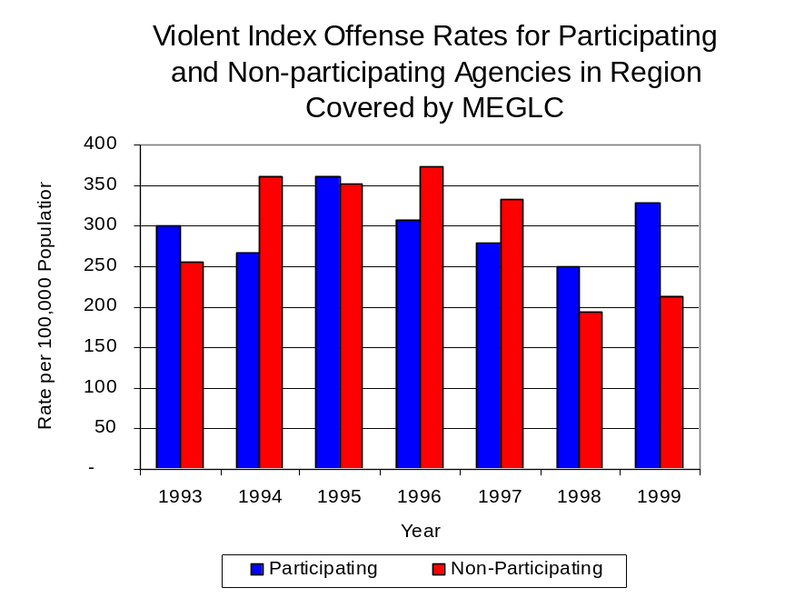
Figure 1
Source: ICJIA calculations using Illinois State Police and U.S. Census

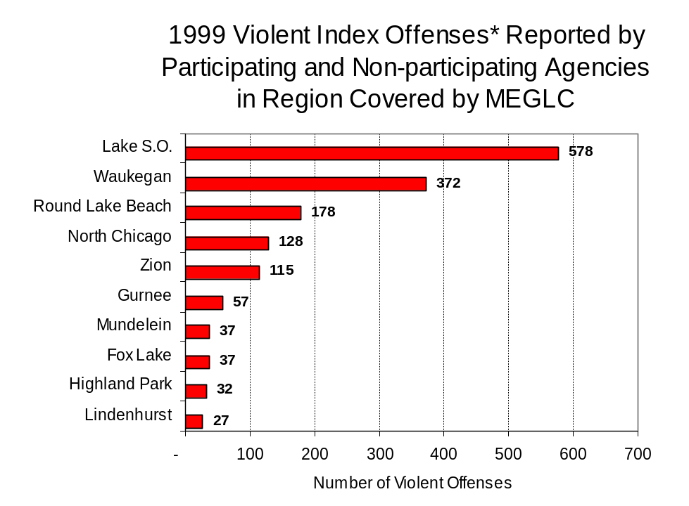
Across the 34 individual local law enforcement agencies covered by MEGLC’s jurisdiction, two agencies, the Lake County Sheriff's Office and the Waukegan Police Department, accounted for over one-half (55 percent) of all violent offenses reported to the police (Figure 2). Twenty-three agencies had fewer than 25 violent offenses reported in 1999 and are excluded from Figure 2. When controlling for differences in the populations served by these law enforcement agencies, the violent Index offense rate ranged from zero violent Index offenses per 100,000 population in Bannockburn and Deer Park to 1,045 offenses per 100,000 population in Hainesville.
Figure 2
Source: Illinois State Police*Agencies with 25 or more violent offenses

An indicator of the workload that law enforcement agencies place on other components of the justice system is the number of arrests made by police, including those for violent and property Index offenses and drug offenses. Unlike offenses, which are what police must respond to, arrests represent those offenders who may eventually be processed through other components of the justice system, including the courts, county jails, and state and local correctional programs.

Between 1993 and 1999, the number of arrests for violent Index offenses made by law enforcement agencies in Lake County increased 49 percent, from 776 to 1,154. As with reported violent Index offenses, the majority (79 percent) of violent Index arrests were for aggravated assaults, followed by robberies (11 percent).

During the period analyzed, the violent Index arrest rate, which takes into account the substantial increase in the Lake County population during the period, for Lake County increased 32 percent, from 148 offenses per 100,000 population in 1993 to 195 arrests per 100,000 population in 1999. Similarly, the violent Index arrest rate in the participating agencies increased 29 percent, from 179 to 231 offenses per 100,000 population and the rate in the non-participating agencies increased 47 percent, from 73 to 108 offenses per 100,000 population (Figure 3).

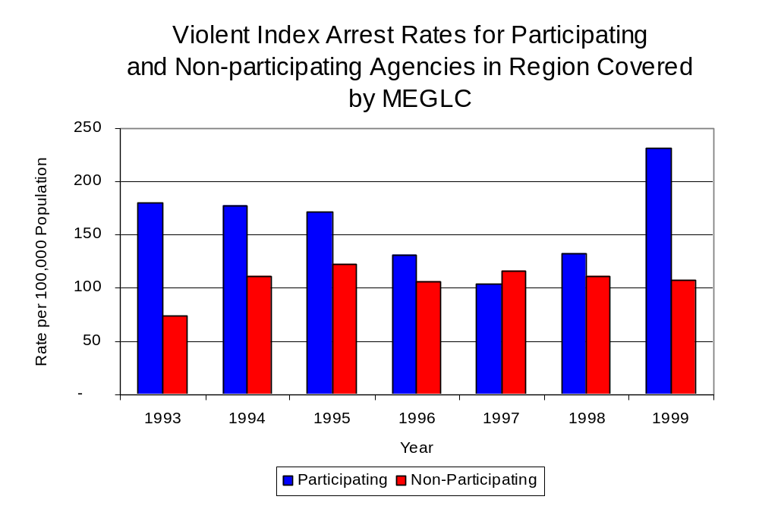
Figure 3
Source: ICJIA calculations using Illinois State Police and U.S. Census

Similar to the number of violent Index offenses, the majority (71 percent) of arrests for violent Index offenses occurring in Lake County were made by three agencies. Nearly three-quarters (25) of the agencies had fewer than 20 arrests for violent Index offenses reported in 1999 and are excluded from Figure 4. Of the 1,154 violent Index arrests made in 1999, the Lake County Sheriff's Office accounted for the largest proportion (38 percent), followed by Waukegan (17 percent) and Round Lake Beach (16 percent) (Figure 4).
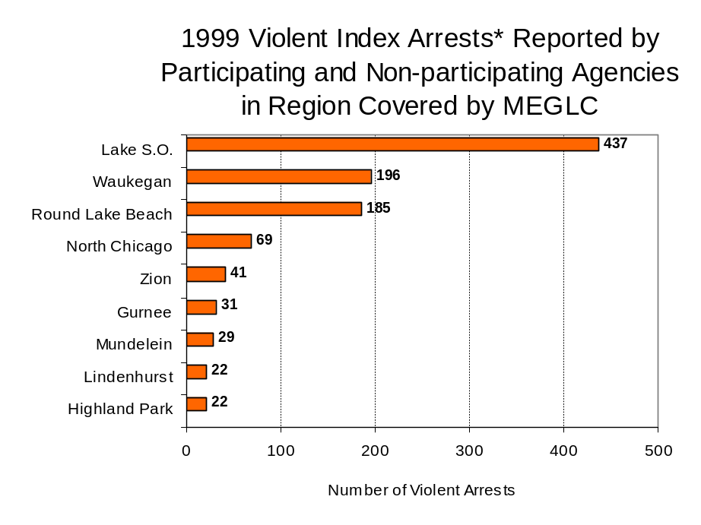
Figure 4
Source: Illinois State Police* Agencies reporting 20 or more violent arrests
III. Trends in Drug Arrests

There are two sources of drug arrest data presented in this section. One source is the Illinois Uniform Crime Reporting (I-UCR) program that includes information submitted by local law enforcement agencies on the number of persons arrested for violations of Illinois’ Cannabis Control Act, Controlled Substances Act, Hypodermic Syringes and Needles Act, and Drug Paraphernalia Control Act. In addition, data on drug arrests made by Illinois’ MEGs and task forces are reported to the Illinois Criminal Justice Information Authority. In some jurisdictions, arrests made by the MEG or task force may be reported by both local law enforcement agencies through the I-UCR and to the Authority by the unit. In other jurisdictions, arrests made by the MEG or task force are only reported to the Authority by the unit. Therefore, in some instances drug arrests may be double counted – included in both local agency statistics reported to I-UCR and those of the MEG or task force. Currently there is no mechanism in place to ensure that drug arrest statistics are not being duplicated at both the local agency and MEG/task force level. This should be kept in mind when interpreting the information presented in the following section.

The majority of drug offenses in Illinois are violations of either the Cannabis Control Act – which prohibits the possession, sale and cultivation of marijuana – or the Controlled Substances Act – which prohibits the possession, sale, distribution or manufacture of all other illegal drugs, such as cocaine and opiates. Illinois also has various other laws prohibiting other drug-related activity. These include the Hypodermic Syringes and Needles Act – which prohibits the possession or sale of hypodermic instruments – and the Drug Paraphernalia Control Act – which prohibits the possession, sale or delivery of drug paraphernalia. In general, violations of Illinois Controlled Substances Act are considered to be more serious, since they primarily involve cocaine, heroin, methamphetamine, and hallucinogens, and are almost all classified under Illinois law as felonies. The majority of cannabis and drug paraphernalia offenses encountered by police, on the other hand, tend to be misdemeanor-level offenses.

In 1999, local law enforcement agencies in the county covered by MEGLC reported 2,820 arrests for drug law violations, nearly double the number in 1993 (1,503 arrests). Between 1993 and 1999, arrests for violations of Illinois’ Cannabis Control Act consistently out-numbered arrests for violations of the Controlled Substances Act in Lake County. During the same period, the number of arrests for violations of the Cannabis Control Act in Lake County increased 134 percent, from 773 to 1,812, while arrests for violations of the Controlled Substances Act increased 38 percent, from 730 to 1,008. In addition, arrests for violations of the Drug Paraphernalia Control Act, enacted in 1993, increased dramatically from 73 in 1993 to 785 in 1999. Much of this increase can be attributed to a 1994 addition to the Drug Paraphernalia Control Act, which included the possession of drug paraphernalia as a violation.

Because arrests for violations of the Drug Paraphernalia Control Act are frequently made in conjunction with other drug offense arrests, these arrests may be double-counted, thus skewing the actual number of drug arrests. Therefore, only arrests for violations of the Cannabis Control Act and Controlled Substances Act will be used for drug arrest comparisons between MEGLC and the participating and non-participating agencies.

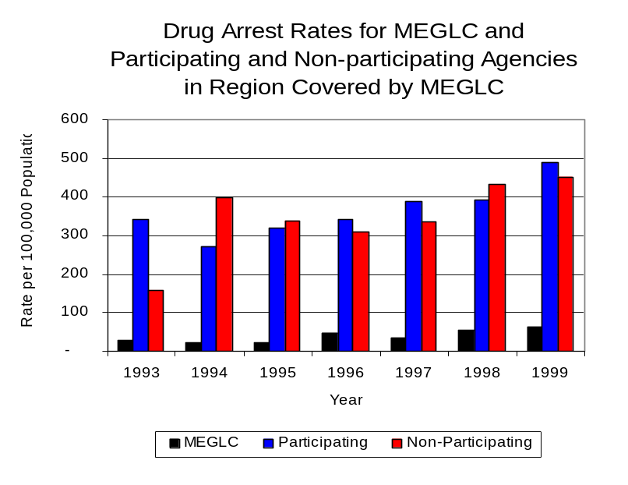
During the period analyzed, the drug arrest rate for the Cannabis Control and Controlled Substances Acts combined, in Lake County, increased 67 percent, from 287 arrests per 100,000 population in 1993 to 477 arrests per 100,000 population in 1999. The drug arrest rate in the participating agencies increased 43 percent, from 341 to 488 arrests per 100,000 population, while the drug arrest rate in the non-participating agencies nearly tripled, from 156 to 450 arrests per 100,000 population. The drug arrest rate for MEGLC more than doubled, from 30 to 62 arrests per 100,000 population (Figure 5). Thus, the drug arrest rate was slightly higher in the jurisdictions that participated in MEGLC, for four out of the seven years analyzed, than in those jurisdictions that did not participate in MEGLC. Although, the drug arrest rate achieved by MEGLC was significantly lower than the rate experienced by both the participating and non-participating agencies, the rates indicate that the unit made one arrest for a violation of the Cannabis Control or Controlled Substances Acts, with 18 officers, for every eight arrests made by all of the participating agencies combined and seven arrests made by all of the non-participating agencies combined.
Figure 5

Source: ICJIA calculations using Illinois State Police, MEGLC and U.S. Census Bureau data
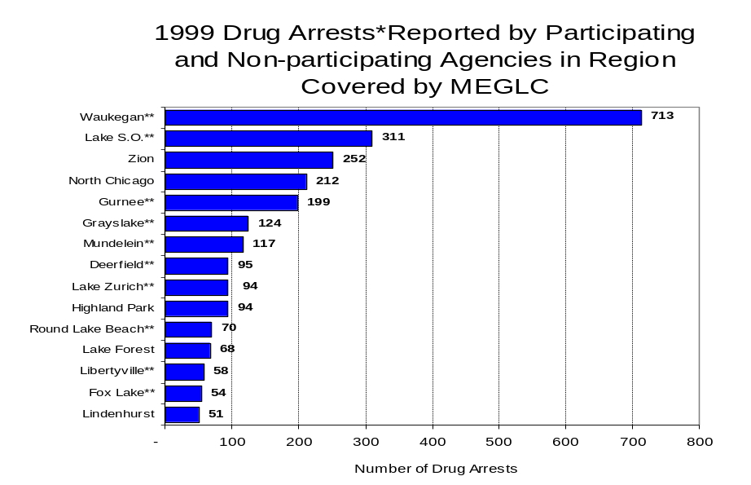
Across the individual, local law enforcement agencies in the region covered by MEGLC, the total number of cannabis and controlled substance arrests ranged from one to 841. Of the 2,820 drug arrests made during 1999 in Lake County, four agencies accounted for more than one-half of these drug arrests. Nineteen agencies had fewer than 50 drug arrests reported in 1999 and are excluded from Figure 6. Waukegan accounted for the largest proportion (25 percent) of all drug arrests in Lake County, followed by the Lake County Sheriff’s Office (11 percent), Zion (9 percent) and North Chicago (8 percent) (Figure 6). Among the 15 agencies with the highest number of drug arrests during 1999, ten participated in MEGLC.
Figure 6
Source: Illinois State Police *Agencies reporting 100 or more drug arrests
**Agencies participating in MEGLC

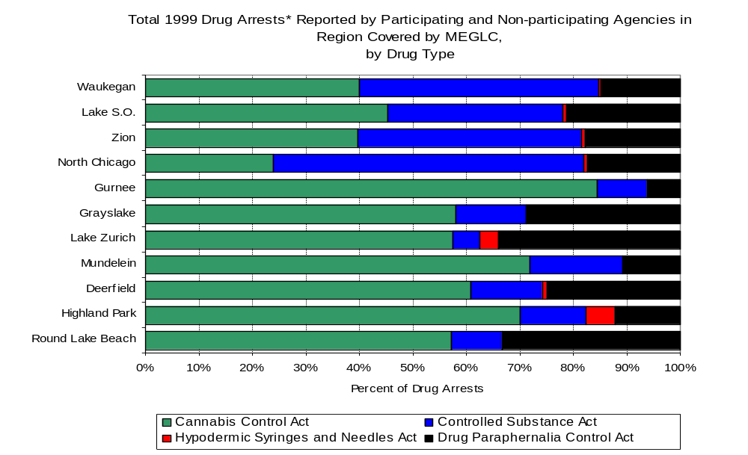
In addition to the dramatic difference in the number of drug arrests made, there are also differences in the types of drug law violation arrests across the agencies in the region. In 1999, violations of the Cannabis Control Act accounted for the largest proportion of arrests across most individual agencies in Lake County (Figure 7).
Figure 7
Source: Illinois State Police*Agencies reporting 100 or more arrests

Between 1993 and 1999, the number of combined cannabis and controlled substances arrests made by MEGLC almost tripled, from 109 to 261 (Figure 8). Unlike drug arrests made by most local police departments in the region, violations of the Controlled Substances Act accounted for the majority of drug arrests made by MEGLC throughout the period analyzed. During the period analyzed, the number of MEGLC arrests for violations of the Cannabis Control Act nearly doubled, from 49 to 96, while arrests for violations of the Controlled Substances Act nearly tripled, from 60 to 165 (Figure 8).

Between 1993 and 1999, the proportion of drug arrests accounted for by violations of the Controlled Substance Act decreased for MEGLC and participating agencies, while increasing for non-participating agencies. In 1999, 63 percent of the drug arrests made by MEGLC were for violations of the Controlled Substances Act, compared to 97 percent in 1993. Similarly, in 1999, arrests for violations of the Controlled Substances Act accounted for one-half of the drug arrests made in the participating agencies in 1993, compared to 32 percent in 1999. Conversely, arrests for violations of the Controlled Substances Act accounted for 39 percent of total drug arrests for the non-participating agencies, compared to 45 percent in 1999. Thus, arrests by MEGLC were more likely than arrests by participating agencies to involve violations of Illinois’ Controlled Substances Act, as opposed to the Cannabis Control Act. One interpretation of this pattern is that while MEGLC is more focused in who they are targeting and arresting than local departments, and are also getting a more serious drug law violator, since violations of the Controlled Substances Act are more likely to involve felony-level offenses.

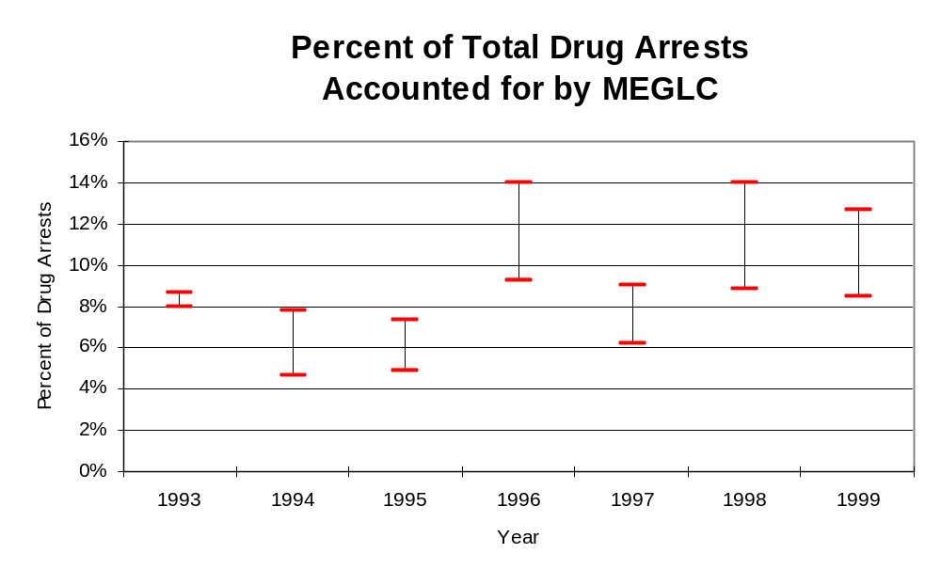
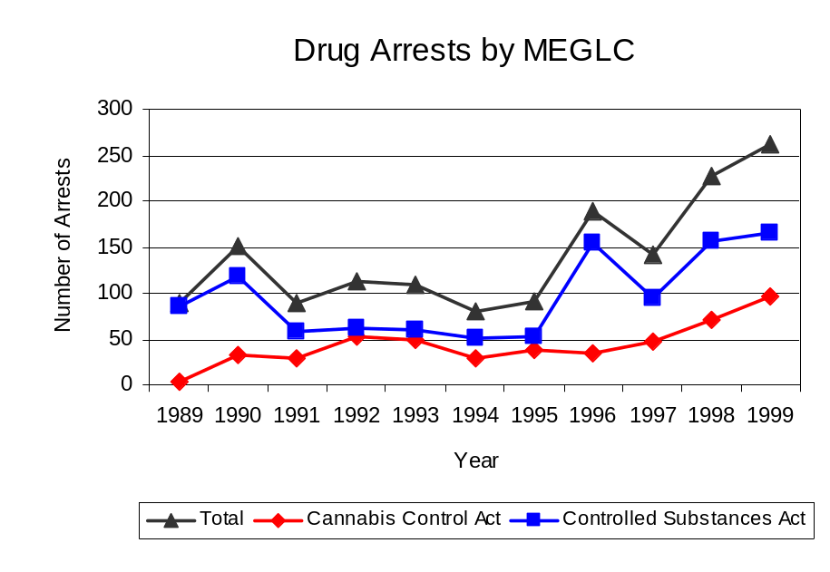
The data presented below represent the percent of total drug arrests made by agencies participating in MEGLC accounted for by MEGLC. An upper and lower bound is shown in Figure 9 which accounts for whether or not the units numbers are counted as part of the UCR submissions made by local departments (which is unknown at this point). The upper bound indicates the percentage of arrests if all of the MEGLC arrests are included in the local UCR submissions. The lower bound indicates the percentage if none of the MEGLC arrests are included in the local UCR submissions. It is estimated that the proportion of all drug arrests across participating agencies accounted for by MEGLC was between 8 to 9 percent in 1993, but increased to between 8 to 13 percent in 1999. Thus, despite the fact that the officers assigned to MEGLC accounted for a small proportion of total officers in the region, they accounted for a significant proportion of the drug arrests in the region.
Figure 9
Source: MEGLC
Figure 8
Source: MEGLC
The number of arrests for violations of Illinois’ Cannabis Control Act in Lake County totaled 1,812 in 1999, nearly triple the 773 arrests made for cannabis violations in 1993. Between 1993 and 1999, the proportion of all drug arrests accounted for by violations of the Cannabis Control Act in Lake County increased during the period, increasing from 51 percent to 64 percent. Agencies participating in MEGLC accounted for the largest portion (68 percent) of the total number of arrests for cannabis violations. MEGLC reported a total of 96 arrests for cannabis violations in 1999, accounting for over one-third (37 percent) of the unit's drug arrests.

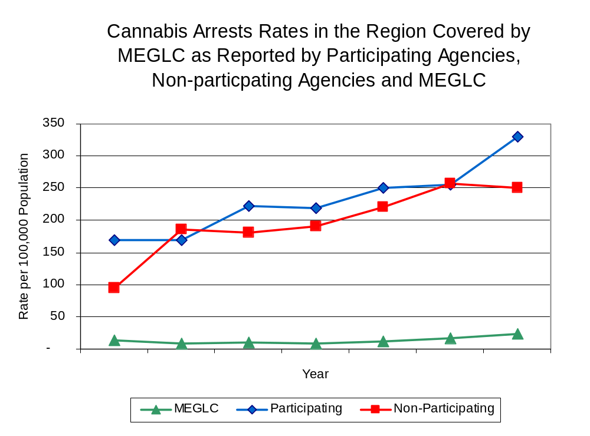
Between 1993 and 1999, the cannabis arrest rate more than doubled for Lake County, increasing from 147 to 307 arrests per 100,000 population. Similarly, the cannabis arrest rate in those agencies participating in MEGLC nearly doubled, from 169 to 330 arrests per 100,000 population, while the non-participating agencies more than doubled, from 95 to 250 arrests per 100,000 population. The cannabis arrest rate for MEGLC increased 72 percent, from 13 in 1993 to 23 arrests per 100,000 population, in 1999 (Figure 10). Thus, the arrest rate for violations of the Cannabis Control Act was collectively higher in the area served by participating agencies than in the combined jurisdictions of the non-participating agencies.
Figure 10
Source: ICJIA calculations using Illinois State Police and MEGLC data

The data presented in Figure 11 represent the percent of cannabis arrests made by agencies participating in MEGLC accounted for by MEGLC. An upper and lower bound is shown which accounts for whether or not the unit’s numbers are counted as part of the UCR submissions made by local departments (which is unknown at this point). The upper bound indicates the percentage of arrests if all of the MEGLC arrests are included in the local UCR submissions. The lower bound indicates the percentage if none of the MEGLC arrests are included in the local UCR submissions. It is estimated that the proportion of cannabis arrests across participating agencies accounted for by MEGLC was between 7 to 8 percent in 1993, but decreased slightly to between 6 to 7 percent in 1999.

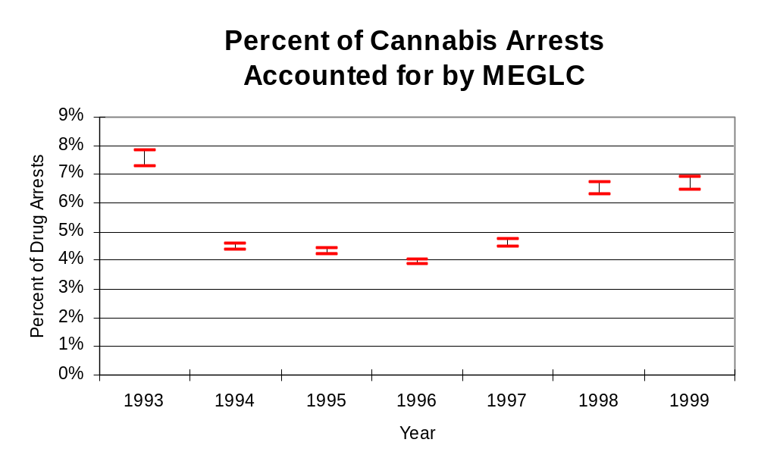
Figure 11
Source: MEGLC
In Lake County, the number of arrests for violations of Illinois’ Controlled Substances Act increased 38 percent between 1993 and 1999, from 730 to 1,008. Between 1993 and 1999, the proportion of all drug arrests accounted for by violations of the Controlled Substances Act in Lake County decreased from 49 percent to 36 percent. Agencies participating in MEGLC accounted for the largest portion (66 percent) of the total number of arrests for controlled substances violations. In 1999, MEGLC reported 165 arrests for controlled substance violations, accounting for nearly two-thirds of all drug arrests reported to the Authority by the unit.

Between 1993 and 1999, the arrest rate for violations of the Controlled Substances Act in Lake County increased 23 percent, from 139 to 171 arrests per 100,000 population (Figure 12). The controlled substances arrest rate in the participating agencies decreased 8 percent, from 172 arrests per 100,000 population in 1993 to 159 arrests per 100,000 population in 1999. However, the arrest rate in the non-participating agencies more than tripled from 61 to 200 arrests per 100,000 population during the same period. The controlled substances arrest rate for MEGLC more than doubled, from 16 to 39 arrests per 100,000 population (Figure 12). Thus, the Controlled Substances Act arrest rate was higher in the non-participating agencies than the participating agencies.

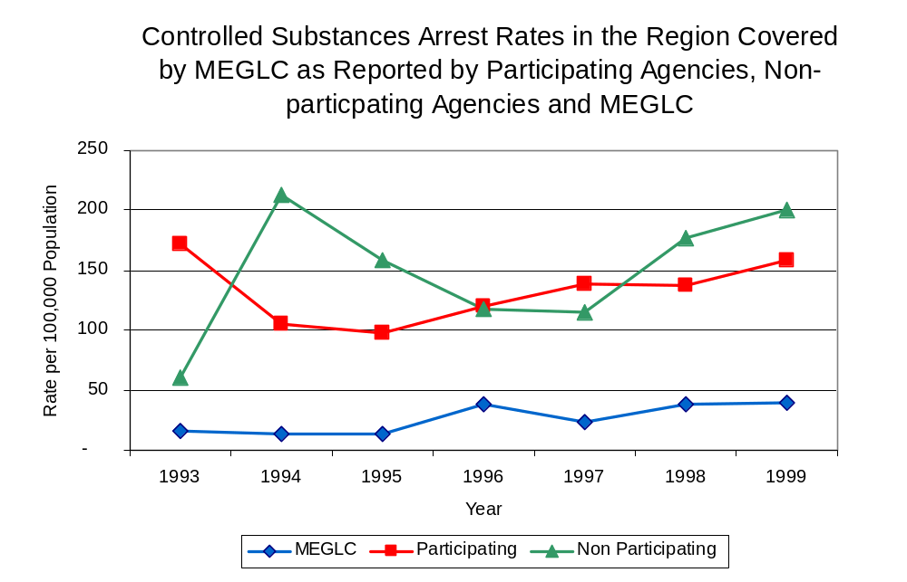
The data presented in Figure 13 represent the percent of controlled substances arrests made by agencies participating in MEGLC accounted for by MEGLC. An upper and lower bound is shown which accounts for whether or not the units numbers are counted as part of the UCR submissions made by local departments (which is unknown at this point). The upper bound indicates the percentage of arrests if all of the MEGLC arrests are included in the local UCR submissions. The lower bound indicates the percentage if none of the MEGLC arrests are included in the local UCR submissions. It is estimated that the proportion of controlled substances arrests across participating agencies accounted for by MEGLC was 9 percent in 1993, which increased to between 20 to 25 percent in 1999.
Figure 12
Source: ICJIA calculations using Illinois State Police and MEGLC data
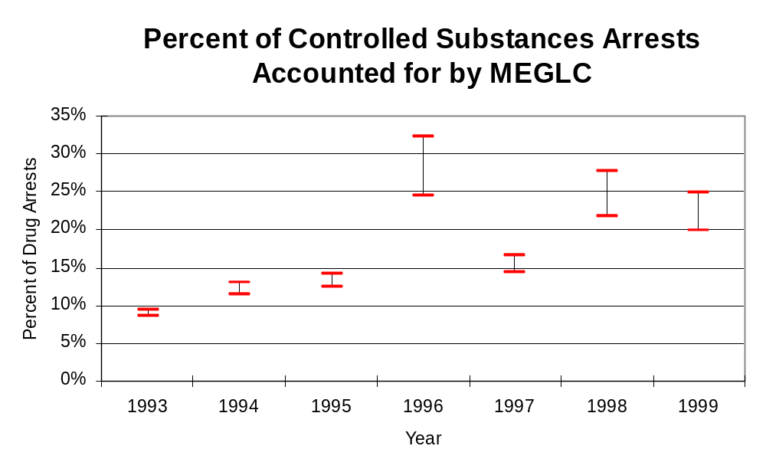
Figure 13
Source: MEGLC
The majority of all drug arrests reported by MEGLC are for delivery. Between 1993 and 1999, the number of drug delivery arrests made by MEGLC increased 50 percent, from 78 to 117. Arrests for drug delivery accounted for 56 percent of all drug arrests made by MEGLC between 1993 and 1999. When cannabis and controlled substance arrests were examined separately, during the period analyzed, arrests for delivery of controlled substances accounted for 63 percent of the total number of arrests made for violations of the Controlled Substance Act, whereas, arrests for the delivery of cannabis accounted for 41 percent of all arrests for violations of the Cannabis Act. Thus, while the total number of arrests for violations of the Cannabis Control and Controlled Substance Acts have increased, between 1993 and 1999, the proportion of arrests that drug delivery arrests accounted for has decreased, from 65 to 39 percent and 77 to 48 percent, respectively.
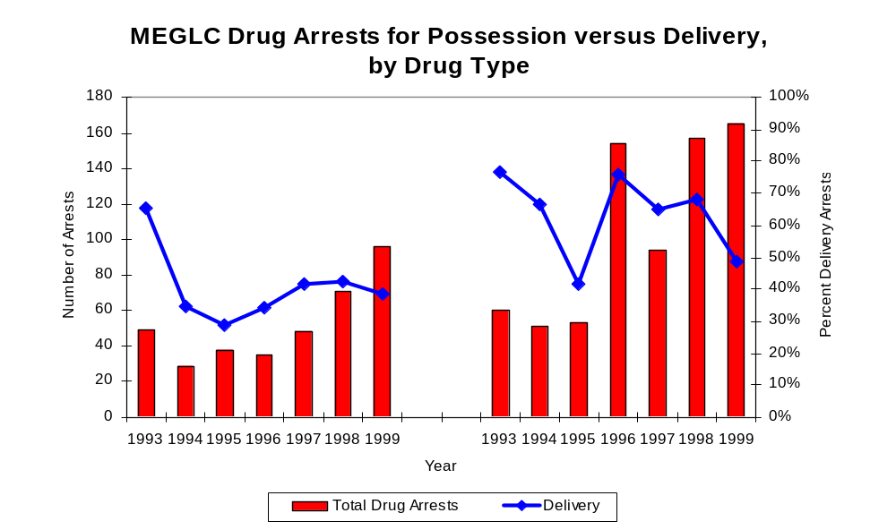
Figure 14
Source: ICJIA calculations using MEGLC data
Cannabis Control Act
Controlled Substances Act

IV. Trends in Drug Seizures

Drugs seized by law enforcement agencies are another indicator of the extent and nature of illegal drug trade in a jurisdiction. When illegal drugs are seized by law enforcement agencies, all or a portion of the total amount seized is submitted to a crime lab for analysis. Most agencies submit drugs to one of the Illinois State Police crime labs. These labs record the quantity of drugs submitted from each county. This section discusses trends in the quantities of illegal drugs seized and submitted to the Illinois State Police and the Northern Illinois Police Crime Laboratory from local law enforcement agencies in Lake County as well as the quantities of drugs seized by MEGLC. It is important to note, however, that while MEGLC data report the total quantities of drugs actually seized, local agency data only represent the quantities of seized drugs that are submitted to the Illinois State Police for analysis. County-level cannabis, cocaine and methamphetamine seizure rates for Illinois' 102 counties are provided in maps located in the Appendix of this report.

As in most Illinois jurisdictions, cannabis accounts for the majority of illegal drugs seized in the region covered by MEGLC. The quantity of cannabis seized and submitted by law enforcement agencies in Lake County decreased 77 percent between 1993 and 1999, from 238,768 grams to 55,502 grams. The quantity of cannabis seized by MEGLC decreased 16 percent, from 336,317 grams in 1993 to 281,664 grams in 1999. (Figure 15). In 1999, MEGLC's cannabis seizure rate of 67,039 grams per 100,000 population was more than seven times the cannabis seizure rate of 9,395 grams per 100,000 population seized by all law enforcement agencies in Lake County, combined (Map 2).
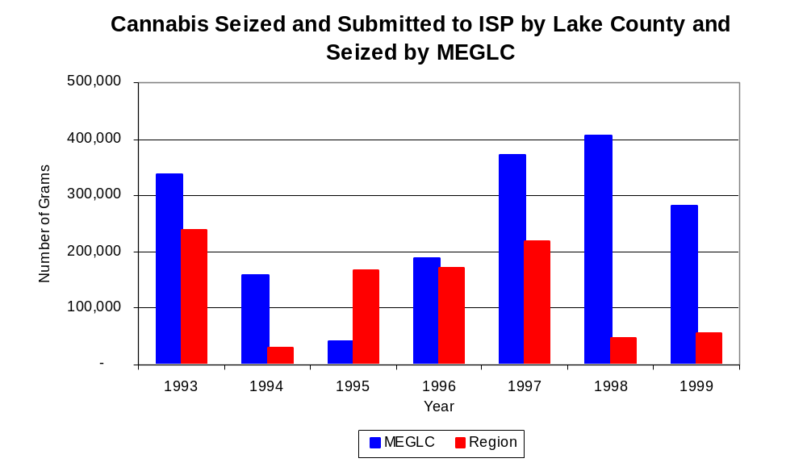
Figure 15
Source: Illinois State Police and MEGLC
Between 1993 and 1999, a combination of crack and powder cocaine has accounted for a small proportion of drugs seized in the region covered by MEGLC. The quantity of cocaine seized and submitted by law enforcement agencies in Lake County more than doubled, from 7,433 grams in 1993 to 16,040 grams in 1999. Similarly, during the same period, the quantity of cocaine seized by MEGLC also more than doubled, from 13,533 grams to 27,805 grams.

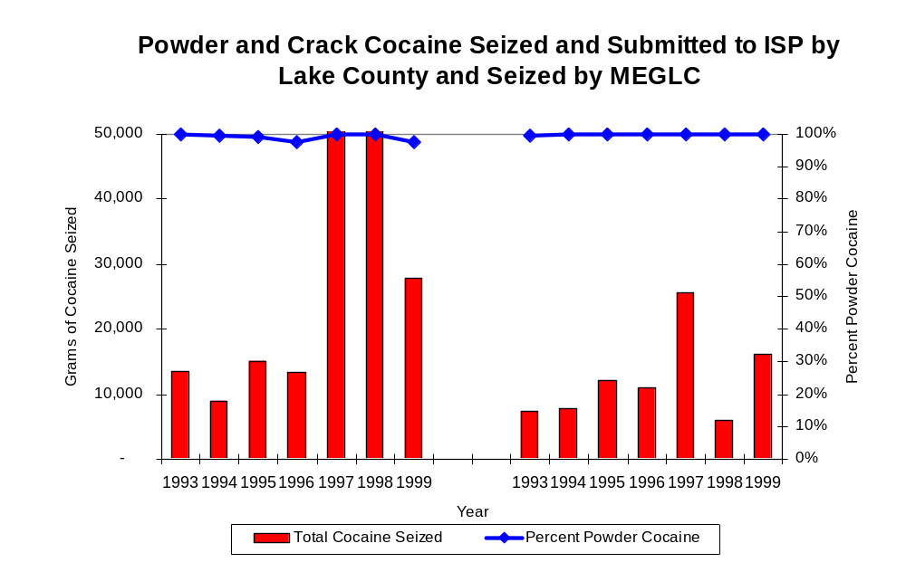
As a result, in both Lake County and for MEGLC, the proportion of all cocaine seized accounted for by powder cocaine remained stable throughout the period, accounting for nearly all cocaine seized between 1993 and 1999 (Figure 16). In 1999, MEGLC's cocaine seizure rate of 6,618 grams per 100,000 population was nearly triple the cocaine seizure rate of 2,715 grams per 100,000 population in Lake County (Map 3).
Figure 16
Source: Illinois State Police and MEGLC
MEGLC
Region

The total quantity of illegal drugs seized and submitted by law enforcement agencies in Lake County decreased 70 percent between 1993 and 1999, from 246,283 grams to 74,521. Although the total quantity of illegal drugs seized by MEGLC has increased 11-fold between 1989 and 1999, from 26,349 grams in 1993 to 315,947 grams in 1999, the quantity of illegal drugs seized by MEGLC has decreased 11 percent, from 350,558 grams in 1993 to the present.

During the period, methamphetamine seizures accounted for a relatively small proportion of total drugs seized by MEGLC and law enforcement agencies in Lake County. Between 1993 and 1999, only five grams of methamphetamine were reported seized by MEGLC. Although the quantity of methamphetamine seizures by law enforcement agencies in Lake County increased slightly, from 0.2.to .47 grams, during the period analyzed, 41 grams and 67 grams were seized in 1995 and 1998, respectively. In 1999, Lake County had a methamphetamine seizure rate of less than one (0.8) grams per 100,000 population, significantly lower than the statewide seizure rate of 98 grams per 100,000 population, respectively (Map 4).

Trends in Prosecutions for Drug Offenses and All Felonies

Although Illinois has one of the best court reporting systems in the country, the Administrative Office of the Illinois Court only collects information regarding the aggregate number of court filings. Currently, there are no statewide data available on court filings by offense type. The Administrative Office of the Illinois Courts reports data on felony criminal court cases. After screening a case and deciding it warrants further action, the state’s attorney must file formal charges in court. Felony cases can be punished by a probation term up to four years and incarceration for more than one year.

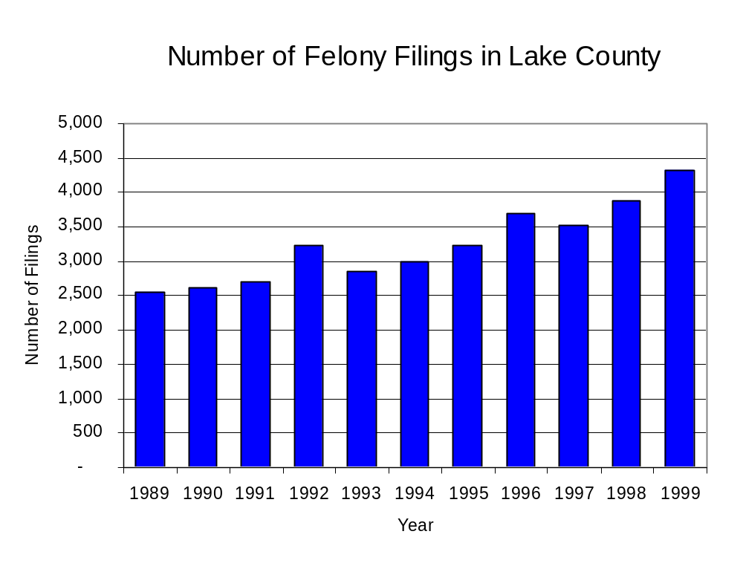
Between 1989 and 1999, the number of felony filings in Lake County increased nearly every year. During the period analyzed, the number of felony filings increased 66 percent, from 2,560 to 4,318 (Figure 17).
Figure 17
Source: Administrative Office of the Illinois Courts

Between 1989 and 1999, there were 1,700 drug prosecutions initiated as a result of MEGLC arrests in Lake County. During this time, the number of MEGLC drug arrests nearly tripled, from 89 arrests in 1989 to 261 arrests in 1999 (Figure 18). Between 1989 and 1999, a large portion of drug arrests resulted in prosecution. During this period seven out of every ten MEGLC drug offender prosecutions were for violations of the Controlled Substance Act. In some years, the proportion of arrests resulting in a prosecution exceeded 100 percent. This is due to some slight differences in the timing of an arrest and the filings of charges, or could be due to charges, rather than defendants, being reported by the unit. In addition, some offenders have charges filed, and a subsequent warrant issued, without an arrest taking place.
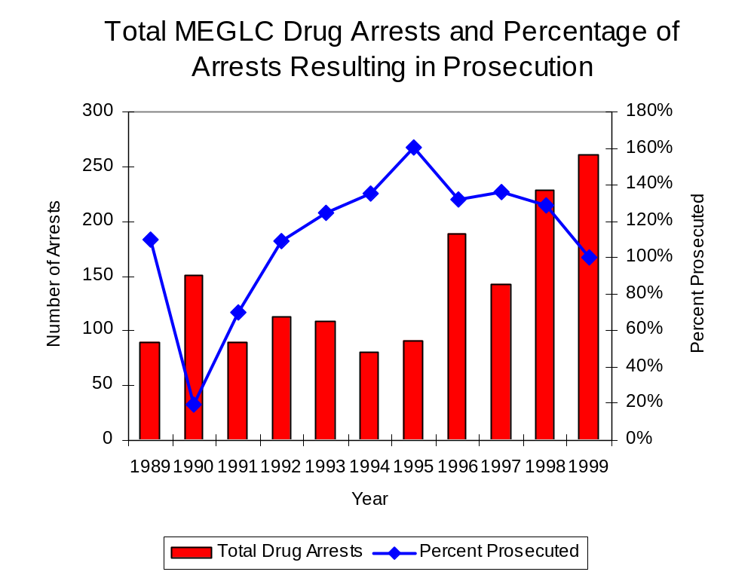
Figure 18
Source: MEGLC

Between 1989 and 1999, 59 percent (996) of the 1,700 drug offenders who were prosecuted as a result of MEGLC activity were convicted. Convictions for controlled substances accounted for 72 percent of all MEGLC initiated convictions during the period analyzed.

VI. Trends in Percent of Convicted Drug Offenders Sentenced to Prison

Anyone convicted of a felony in Illinois can be sentenced either to prison or probation, or receive conditional discharge. A number of factors influence the type and length of sentence imposed on convicted felons, including the severity of the crime, the offender’s criminal and social history, safety of the community and legislation affecting certain types of offenses. For some types of convictions, a sentence to prison is required by state statute.

Between 1989 and 1999, the number of offenders convicted of a felony and sentenced in Lake County increased 20 percent, from 1,279 to 1,531. The number of convicted felons sentenced to the Illinois Department of Corrections (IDOC) nearly doubled between 1989 and 1999, from 414 to 803. Consequently, the proportion of felons sentenced to IDOC increased during the same period, from 32 percent to 36 percent of total felony sentences. In 1999, 1,355 probation sentences were imposed on convicted felons, 17 percent more than the 861 probation sentences in 1989 (Figure 19). As a result, the proportion of felons sentenced to probation decreased from 67 percent in 1989 to 60 percent in 1999. Sentences other than prison or probation account for the remaining 4 percent of felony sentences imposed in 1999.
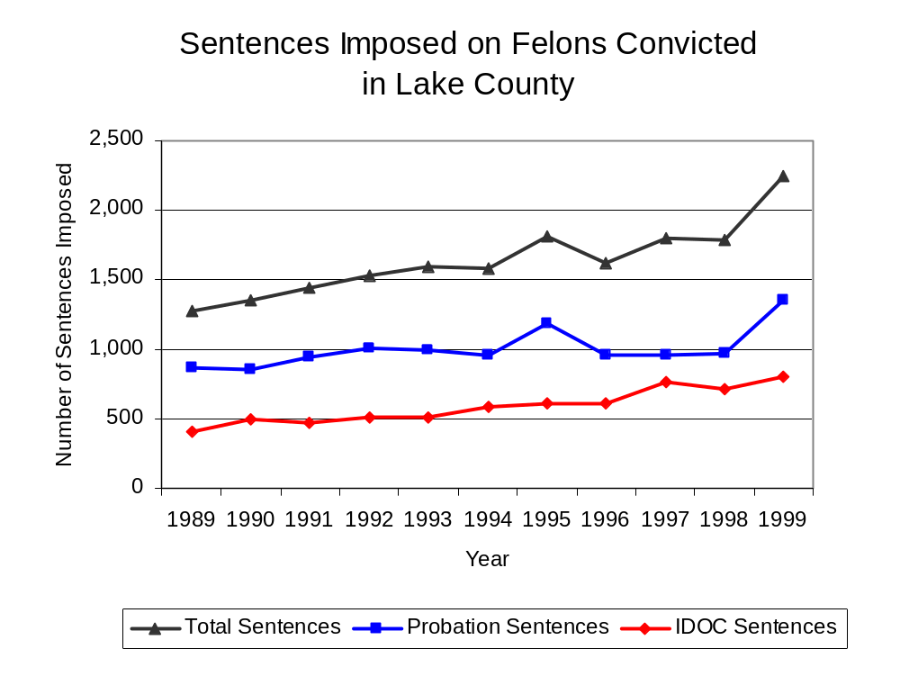
Figure 19
Source: Administrative Office of the Illinois Courts

Between 1989 and 1999, the number of MEGLC drug offenders convicted and sentenced more than doubled, from 98 to 261. During the period analyzed, the number of convicted MEGLC drug offenders sentenced to prison increased 26 percent, from 31 to 39. The number sentenced to probation increased 88 percent, from 33 to 62, while the number of convicted MEGLC drug offenders sentenced to jail more than doubled, from 10 to 24 (Figure 20). In 1999, among those MEGLC drug offenders convicted and sentenced, probation sentences accounted for the largest proportion (50 percent), followed by prison sentences (31 percent) and jail sentences (19 percent).

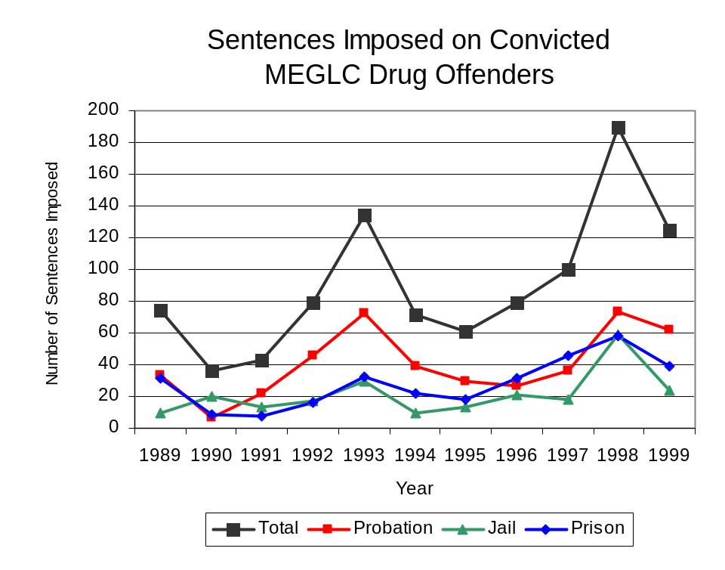
Figure 20
Source: MEGLC

Between state fiscal years 1989 and 1999, the number of new court commitments to IDOC’s Adult Division for drug offenses from Lake County more than tripled, from 82 to 251. The number of drug offender admissions by MEGLC also increased (57 percent), from 28 to 34 between 1989 and 1999 (Figure 21). Thus, during the period analyzed, prison sentences resulting from MEGLC cases accounted for 16 percent of all drug-law violators sentenced to prison from the region where MEGLC operates.
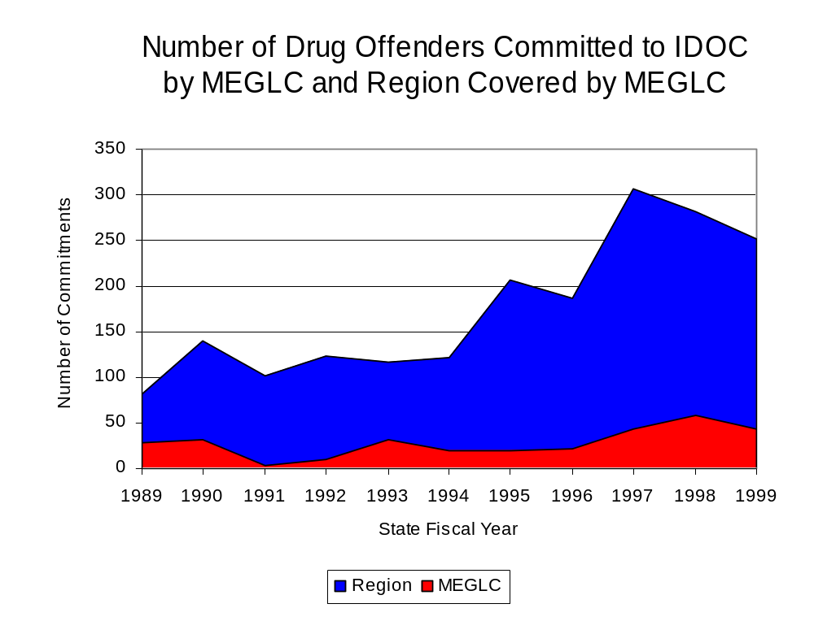
Figure 21
Source: Illinois Department of Corrections and MEGLC

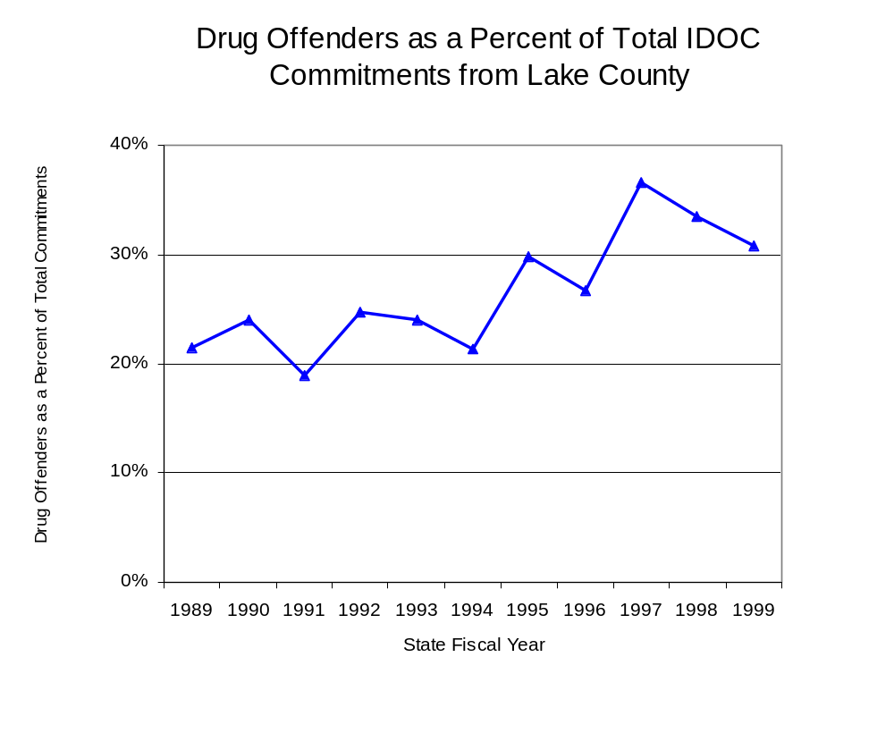
During the period analyzed, drug offenders accounted for an increased proportion of adults convicted and sentenced to prison from Lake County. In 1989, drug offenses accounted for 21 percent of all commitments to IDOC, compared to 31 percent in 1999 (Figure 22).
Figure 22
Source: Illinois Department of Corrections

Penalties for drug offenses were also examined between 1993 and 1999. Class 4 felonies accounted for the largest proportion (53 percent) of sentences to IDOC for drug offenses, followed by Class 1 felonies (23 percent), Class 2 felonies (12 percent), Class X felonies (10 percent) and Class 3 felonies (3 percent). Between 1993 and 1999, the number of Class 4 felony sentences almost tripled, from 51 to 150, while Class 1 felony sentences more than doubled, from 25 to 53 as did Class 2 felony sentences, increasing from nine to 24. The number of Class X felonies increase almost five-fold, from four in 1993 to 19 in 1999, while Class 3 felonies decreased from eight to five, during the same period (Figure 23).

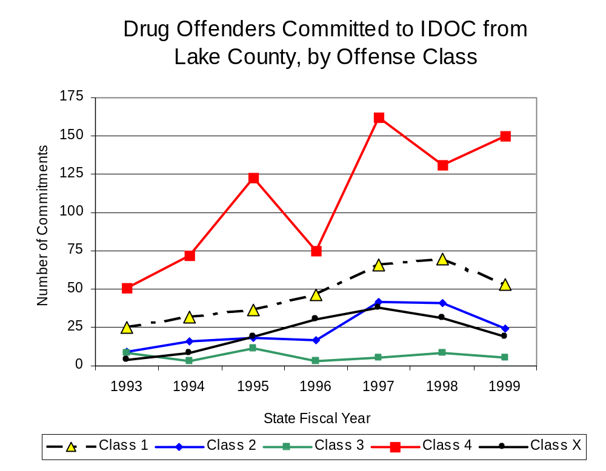
Figure 23

Source: Illinois Department of Corrections
Despite the increase in Class 4 felony sentences to IDOC between 1993 and 1999, the mean sentence length for Class 4 felonies decreased 16 percent, from 2.5 to 2.1 years during the period. Mean sentence lengths for Class X felonies decreased from 11 to 8.1 years, while mean sentence lengths for Class 2 felonies decreased 7 percent, from 4.3 to 4 and mean sentence lengths for Class 1 felonies decreased 5 percent, from 5.6 to 5.3. Conversely, the mean sentence length for Class 3 felonies increased 8 percent, from 2.5 to 2.7 years.

VII. Trends in Drug Treatment Admissions in MEGLC Region by Drug Type

In addition to considering indicators of the extent and nature of drug abuse as reported through the criminal justice system (for example, arrests and prison sentences), there are indicators of substance abuse available from other Illinois social service agencies. Overseeing and supporting treatment for substance users, whether they are referred from the criminal justice system or elsewhere, is the responsibility of the Illinois Department of Human Services’ Office of Alcoholism and Substance Abuse (OASA). It is important to note, however, that while OASA data represent the majority of the overall demand for substance abuse treatment in the state, some private programs provide treatment services to a smaller but significant number of clients who may not be included in the state’s reporting system.

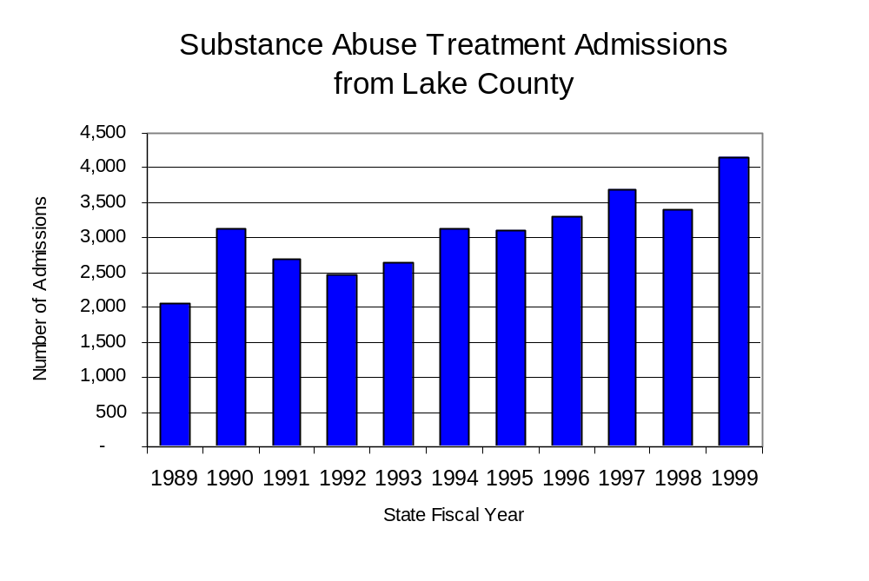
In state fiscal year 1999, OASA reported 4,156 admissions for alcohol or drug abuse treatment from Lake County, which more than double the 2,055 admissions in 1989 (Figure 24). Among the 4,156 admissions to substance abuse treatment in state fiscal year 1999, (55 percent (2,266) reported illicit drugs as their primary substance of abuse, while abuse of alcohol accounted for 42 percent (1,752) and 3 percent (138) reported no primary substance of abuse.
Figure 24
Source: Illinois Department of Human Services’
Office of Alcoholism and Substance Abuse

While drug treatment admissions can be considered a measure of the demand placed on a specific component of the human services system within Illinois, the extent and nature of drug treatment admissions could also be indicative of the substance abuse problem within a particular region. In some respects, the characteristics of those admitted to drug treatment can be considered a profile of the most serious drug abusers in the community, since admission to treatment requires a documented, formal assessment of a drug problem and a level of substance abuse warranting treatment. By comparing the types of drugs of abuse reported by those admitted to substance abuse treatment with the types of drugs involved in law enforcement agency arrests, one can get a sense of the degree to which arrests reflect the drugs which are most problematic within a community.

In the following analyses, the percent of arrests accounted for by drugs classified under Illinois’ Controlled Substances Act (primarily cocaine, heroin, and methamphetamine) versus the Cannabis Control Act (marijuana) across the participating agencies combined, non-participating agencies combined and MEGLC are compared to the proportion of drug treatment admissions accounted for by these groups of substances. From these comparisons, a number of general conclusions can be made. First, the proportion of arrests made by MEGLC accounted for by drugs other than marijuana (Controlled Substances Act offenses) was very close to the proportion of drug treatment admissions from the covered region accounted for by these substances. Thus, there is considerable convergence between the drugs involved in MEGLC arrests and treatment admissions. On the other hand, the majority of arrests by local police departments (including those participating in MEGLC and non-participating agencies) were for cannabis offenses. Thus, while local arrests may reflect the most widely available and used drug in the region, they tend not to involve the substances considered to be most serious (i.e., felony versus misdemeanor) nor the substances individuals are seeking and receiving treatment for (Figure 25).

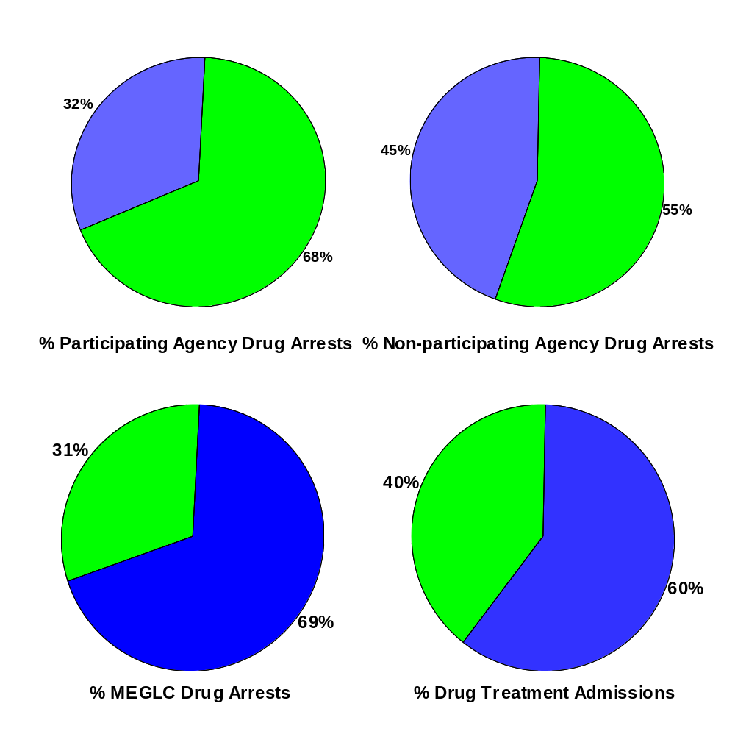
Comparison of Drug Arrests by MEGLC and Participating and
Non-participating Agencies vs. Drug Abuse
Treatment Admissions in Lake County, 1999

Source: Illinois Department of Human Service's Office of Alcoholism and Substance Abuse and SEIDTF
Figure 25
CannabisControlled Substances

VIII. Trends in Drug Exposed Births

Illinois continues to experience the effects of prenatal substance abuse. In Illinois, if a baby is born and thought to have been exposed to illegal substances or alcohol, either through observation by physicians or toxicology tests, the case is reported to the Illinois Department of Children and Family Services. These cases are then investigated by DCFS to verify the child’s prenatal exposure to either alcohol or illegal substances. Between state fiscal years 1989 and 1999, nearly one-half (50) of Illinois’ 102 counties reported at least one case of a substance-affected infant.

Between state fiscal years 1989 and 1999, the number of drug-exposed infant cases reported in Lake County decreased 12 percent, from 41 to 36. Between state fiscal years 1989 and 1999, 452 cases, or 91 percent of all cases reported, were verified as involving prenatal drug use by a DCFS investigation. However, the verified cases of drug-exposed infants in the MEGLC region increased slightly between 1989 and 1999, from 32 to 33 (Figure 26).
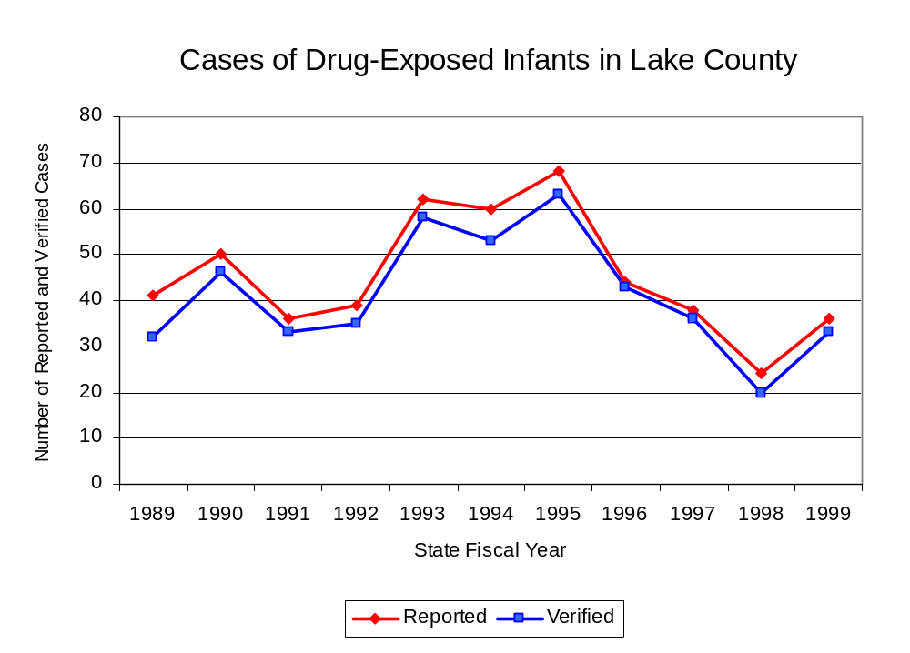
Figure 26
Source: Department of Children and Family Services

IX. Summary of Drug Situation

Although the distribution of illegal drugs is difficult to measure precisely, data obtained from criminal justice sources can be helpful in estimating drug availability. Information from a recent survey of Illinois drug enforcement units, as well as the most up-to-date data available on drug price, are presented as indicators of the drug supply in Illinois.

In 1995, 1996 and 1998, the Authority conducted a survey of each MEG and task force in Illinois to gauge the perceived availability of drugs in the areas they cover. Questions were asked concerning the availability of specific drugs, and results were analyzed by region of the state. MEGs and task forces are classified as being urban, rural or mostly urban based upon the classification of the county(s) that each unit covers, and, for purposes of this report, are compared to the average of similar units.

According to MEGLC survey responses, cannabis, cocaine and crack continued to be the most visible drugs on the street and were all reported to be “readily available” across all regions analyzed. With the exception of LSD, the perceived availability of most drugs remained relatively unchanged in the region covered by MEGLC. The perceived availability of LSD has increased slightly in the region covered by MEGLC and in all other MEGs and task forces in mostly urban regions similar to MEGLC since the 1996 survey, while perceived availability of LSD has decreased slightly across Illinois. Methamphetamine was reported as moderately available across Illinois but available to a somewhat greater degree in Lake County and by all MEGs and task forces in mostly urban regions (Figure 27).
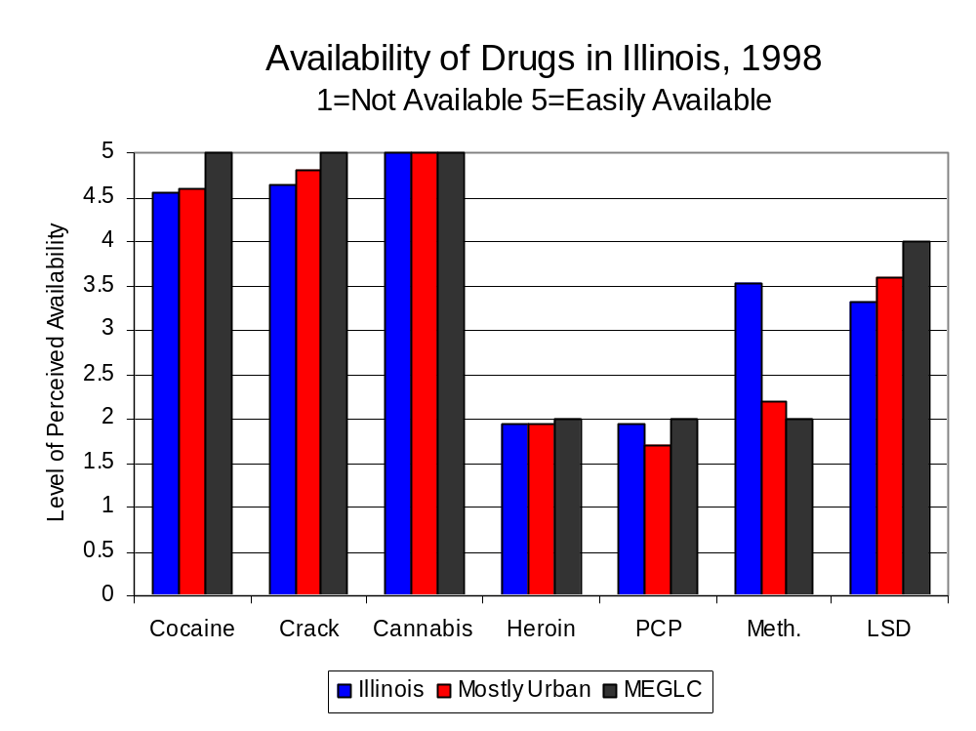
Figure 27
Source: Authority Survey of Illinois MEGs and task forces
Another market indicator that can be used to assess availability is drug price. Lower prices tend to suggest a sufficient supply to meet demand, while increasing prices indicate decreased availability.

Based on a statewide survey of MEG and task force units, the average price of crack, cannabis and heroin appear to be relatively stable across all regions surveyed in 1998, while prices for cocaine, PCP and methamphetamine appear to vary somewhat across Illinois. The average price of cannabis increased between 1996 and 1998 in all regions examined. The average price of cocaine decreased in the MEGLC region and in the other primarily mostly urban regions, while increasing slightly across Illinois. In addition, the average price of crack decreased across Illinois and in all MEGs and task forces in other mostly urban regions, while r3emaining unchanged in the region covered by MEGLC The 1998 average price of cocaine reported across Illinois was $98 per gram, compared to the $75 reported by MEGLC and $89 per gram reported by all MEGs and task forces in other mostly urban regions (Figure 28). In 1998, the average price of cannabis was reported as approximately $10 per gram in the MEGLC region, $11 per gram in primarily mostly urban regions and $8 per gram across Illinois. Also in 1998, the average price of crack was reported as approximately $100 per gram in the MEGLC region, $92 per gram in primarily mostly urban regions and $102 per gram across Illinois.
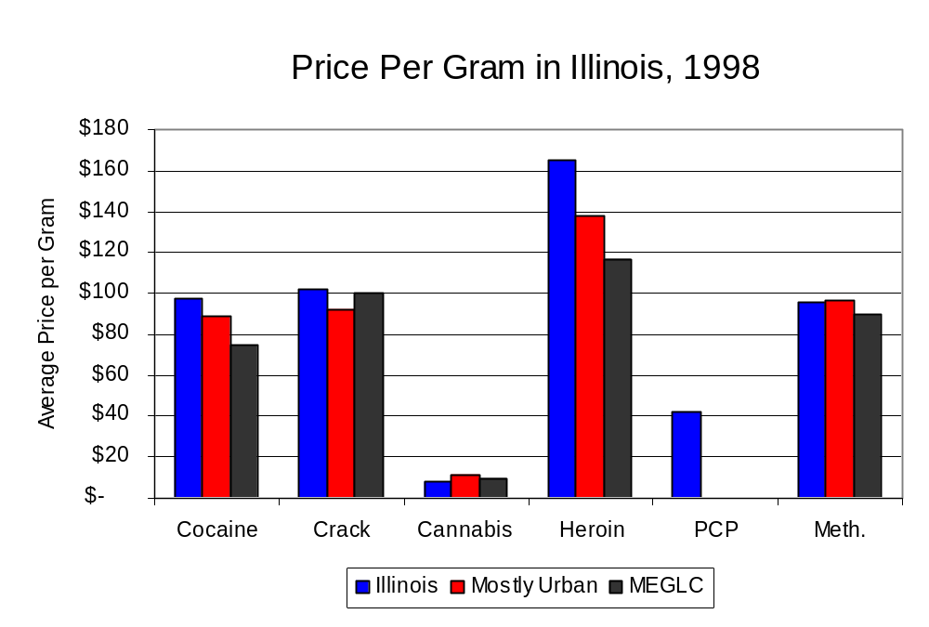
Figure 28
Source: Authority Survey of Illinois MEGs and task forces

X. Appendices
1999 Percent of Illinois'
County-level Population Covered by an Authority-funded Multi-jurisdictional Enforcement Group or Task Force
Map 1
* Shaded counties indicate that at least one law enforcement agency within the county participates in a MEG or task force
Percent of County Population Covered by MEG or Task Force

1999 Illinois
Cannabis
Seizure Rates, by County
Map 2
Cannabis Seizure Rate
(rate per 100,000 population)
1999 Illinois
Cocaine
Seizure Rates, by County
Map 3
Cocaine Seizure Rate
(rate per 100,000 population)
1999 Illinois Methamphetamine
Seizure Rates, by County
Map 4
Methamphetamine Seizure Rate
(rate per 100,000 population)

Bibliography

Administrative Office of the Illinois Courts, Annual Report to the Supreme Court of Illinois.
1989 through 1999 reports, Springfield, Illinois.

Administrative Office of the Illinois Courts’ Probation Division, Statewide Probation Data
Report. 1989 through 1999 reports, Springfield, Illinois.

Illinois Department of Human Services’ Office of Alcoholism and Substance Abuse. Data
provided for state fiscal years 1989 through 1999, Springfield, Illinois.

Illinois Department of Children and Family Services, Child Abuse/Neglect Statistics Report,
1989 through 1999 reports, Springfield, Illinois.

Illinois Department of Corrections. Data provided for fiscal years 1989 through 1999,
Springfield, Illinois.

Illinois State Police, Crime in Illinois. 1993 through 1999 reports, Springfield, Illinois.

Illinois State Police, Drug Statistics Report. Monthly reports, January 1989 through
December 1999, Springfield, Illinois.

Lake County Metropolitan Enforcement Group. Monthly reports, January 1989 through
December 1999, Libertyville, Illinois.

U.S. Bureau of the Census.


George H. Ryan, Governor
Peter B. Bensinger, Chairman
Candice M. Kane, Executive Director

